WORKSHEET – 2.2

## Name: Rahul Maurya

## Section/Group: 716 / “B” UID: 20BCS7260

**Subject: Computer Networks Lab Date of Submission: 26.03.2022 Branch: BE CSE (4 Semester)**

**AIM:** Create different network topologies like Star, Bus and Mesh Topology with the help of packet tracer and show the output.

**REQUIREMENTS:** Cisco packet tracer

 

## STEPS FOR EXPERIMENT:

**STAR Topology:**

* Connect different PCs with central hub/switches.
* Assign individual IPs to all PCs
* Drop PDU from one pc to another
* Start Simulation

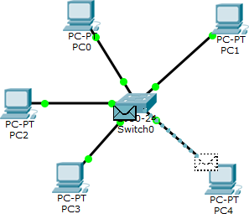

**Mesh Topology:**

* Every device has a dedicated (link carries traffic only between two devices) point to point link to every other device.
* Assign IPs to every individual Pc
* Drop PDU
* Start Simulation

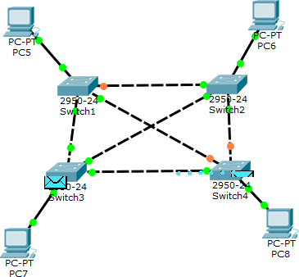

**Bus Topology:**

* All nodes are connected along with this communication line with two endpoints called the bus or backbone
* Connect PCs with switches serially.
* Drop PDU
* Start Simulation

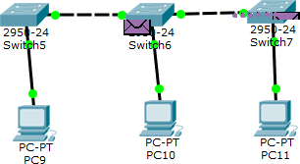

## RESULT:

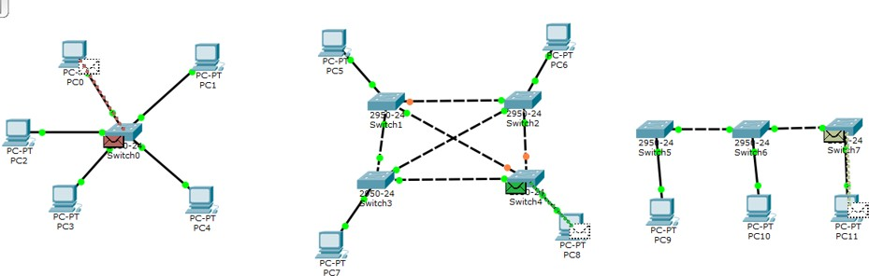

**Star Mesh Bus**

**Learning outcomes (What I have learnt):**

* I understood different network topologies like star, mesh and bus.
* I learnt to use cisco packet tracer.
* I learnt to make diagram of topologies on cisco packet tracer.

# Evaluation Grid (To be created as per the SOP and Assessment guidelines by the faculty):

|  |  |  |  |
| --- | --- | --- | --- |
| Sr.  No. | Parameters | Marks Obtained | Maximum Marks |
| 1. |  |  |  |
| 2. |  |  |  |
| 3. |  |  |  |
|  |  |  |  |